**Introduction:**

**Software engineering** is a field of [engineering](https://simple.wikipedia.org/wiki/Engineering), for [designing](https://simple.wiktionary.org/wiki/design) and [writing](https://simple.wikipedia.org/wiki/Writing) [programs](https://simple.wikipedia.org/wiki/Computer_program) for [computers](https://simple.wikipedia.org/wiki/Computer) or other [electronic](https://simple.wikipedia.org/wiki/Electronics) devices. **Software** means the programs and other operating information used by a computer.

As a part of our software engineering learning, we are doing this project.We hope by the end of this project we will learn the following perspectives :

a) **Which factors are to take in consideration while making an application**

b) **How the total works are modulated and grouped**

c) **How to make a readable, understandable and proper documentation regarding the software including SRS,SDD**

d) **Which factors are preserved to understand people’s demand ,need and user friendliness while designing the application software.**

e) **How to follow and manage the activities of generic process framework (communication,planning, modeling,construction and deployment)**

f) **The Umbrella Activities**

g) **How to understand a problem, plan the solution, carry out the plan and examine the result while completing the project.**

**Our Project:**

Our project name is “Visualization of Genetic Algorithm with MAXONE PROBLEM using Android Operating System.”

Genetic Algorithm basically means a class of probabilistic algorithms,inspired by the biological evolution process . Uses concepts of *“Natural Selection”* and *“Genetic Inheritance”* (Darwin 1859) . This idea was originally developed by John Holland (1975)

Special Features:

i) *Traditionally emphasizes combining information from good parents (crossover)*

ii) *Particularly well suited for hard problems where little is known about the underlying search space.*

iii) *Widely-used in business, science and engineering*

iv) *Mutation,Selection and Crossover operations.*

It’s basically an optimization algorithm.

Simple Genetic Algorithm

1. produce an initial population of individuals (parents)

2. evaluate the fitness of all parents

3. while termination condition not met do

1. select fitter parents for reproduction • evaluate the fitness of each parent

2. recombine between fit parents to make offspring

3. mutate offspring

4. Replace the whole population with the resulting offspring end while

4. output ‘best’ offspring (highest fitness)

The whole process can be diagrammatically found by this -

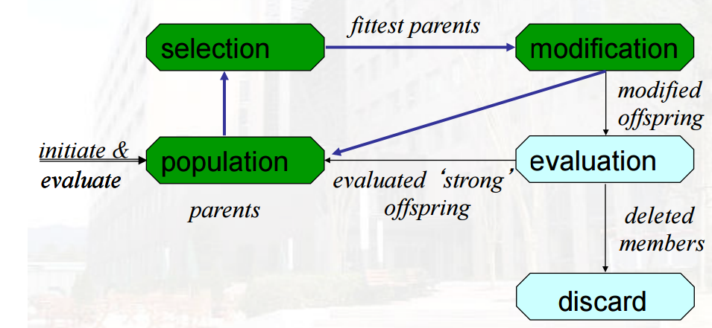

Picture - (collected from the resources of Faculty of Information Science and Engineering Ritsumeikan University )

The **Max One** problem is a very simple problem where evolution is used to find a specific "gene". A gene is essentially a piece of text filled with random binary values (0 or 1), a binary string. We will visualize our genetic algorithm with this MAXONE problem. This is basically an example of the genetic algorithm which shows how our precise algorithm works. Then using the ratio of zeroes and ones we can determine which genome sequence is best and how they can be used to prepare the best crossover and mutation process. There are basically tow

Our whole implementation will be developed for Android operating system(OS). Android is one of the most renowned operating system now a days.Almost every smartphone and smart devices are now a days are built on AOS. So, by building on this platform we can reach a huge amount of people.

**Our Main Target :**

Our main target is to visualize this genetic algorithm using android. Genetic algorithm implies huge level of applications. But we are going to focus on mainly these topics-

**i) Selection**

**ii) Crossover**

**iii) Mutation**

These are basically closely related with genome sequence. Genome sequence determines the characteristics of human nature. These characteristics and operations moderate the genome sequence and thus the characteristics of persons are reformed. So, our target is to visualize them and show how these operations are performed and how the whole process is followed.

SELECTION->CROSSOVER->MUTATION

Our target is to visualize these process using android operating system along with the help of Java and XML. There has been very swift and precise libraries and along with powerful language and media tools for how to do these works.

We are planning to implement the visualization to the fullest sense. Our goal is to make it attractive,swift and beautiful and make user friendly. As, this project is basically visualizing the application of genetic algorithm, it is basically a learning topic. So , we want to build it such a way such that, people of all ages can use the application very easily plus to make the visualization very comfortable and effective for all ages of people.

**Functional Requirements:**

The functions which are we planning to give into our applications are following -

1. User Input - We are planning to give this ideology in our application. User will give some genome sequence,Then we will show how the best quality ful genes are selected, how then on prescribed conditions they meet (crossed) and how then after mutation the whole process is performed.
2. Random Input - This is basically general type of query. We will randomly generate some sequence and show the process. This is mainly a tutorial or can be said as example type.
3. Visualization - The life of our project is this. Our main goal of this application is the visualization of the whole process.

**Use Case Diagram:**

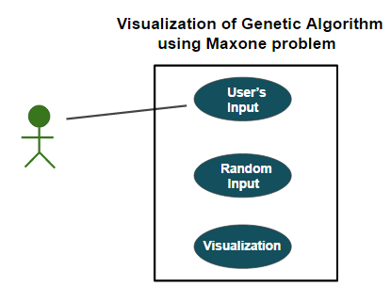

**Development Requirements:**

We are planning to use these materials,reources as our tools for the project.

1. Programming Languages - JAVA, XML.
2. IDEs - Android Studio, Net Beans, Eclipse
3. Emulators - Genymotion Android Emulator
4. Virtual Box
5. Linux operating system

**Graphical User Interface:**

1. User Friendliness - Our application will be very user friendly. We will use light colors for the benefit of the users, easily operating programs and options. They will be designed such that all the procedures are very easily guessable and operable.
2. Interactive - As we are keeping user input and random input system and also option switching system they will be very interactive.
3. Smooth and Attractiveness - This is completely done through efficient coding procedure and along with high graphical system and using high level language.
4. UX Priority - We are giving very high priority on user experience, and user dependency. Our whole application is built on this education topic, so we are giving high priority on the easiness and attractiveness of the topic, such that it can easily attract people and fulfil their wishes and meet their thirsts.

**Requirements:**

1. **Hardware Requirements:** The system will require Android Operating system to run on. There are no needed extra hardware dependencies. Android operating system needs some defined hardware system calls and other calls. Other than that there are no more hardware dependencies.
2. **Software Requirements**:The Software will require Android API Level of 15 or above to run on.Minimum requirements is Ice Cream Sandwich 4.0.3.

**Targeted User and Users’ Expectations:**

The sole purpose of our project is to make people visualize the whole procedure of genetic algorithm. So, people will expect it to be very easy to learn and to understand and besides as it’s a reading purposed topic so we want it to be very easily operated application. Also, as we are publishing it on android operating system, it’s very familiar nowadays, so by this now we can target a huge market. Our topic is very interesting and most of the time, as it’s a topic of almost molecular level in metaphoric sense, most of the time these topics remains absurd. So, visualization of them can serve them really well.

**Specific Advantage:**

1. Attractive User Interface
2. Suitable and attractive graphics
3. Great and ease at understanding
4. Easily operable
5. Convenient to get

**Specific Disadvantage:**

1. At least Ice Cream Sandwitch 4.0.3 version is required
2. Other operating system doesn’t support.